Martin Brown
mbrown@lucid-analytics.com
Abstract
In today’s technology marketplace it is often difficult to determine the correct product or mix of products to fulfill all an organization’s analytical needs. Most solutions are good at one thing or another but rarely is a single product or platform able to provide all the essential capabilities of a robust analytical environment while still maintaining manageability. The truth is, all the essential capabilities really boil down to 3 things: diversity, scale, and trust.
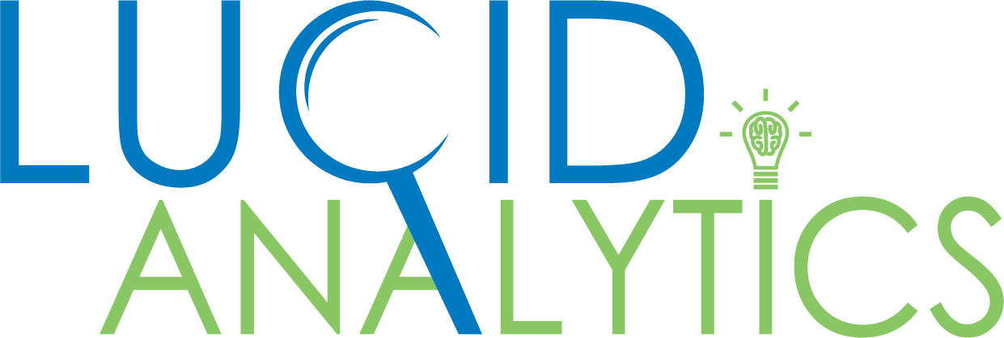
3 Ways SAS Viya Delivers exceptional business value

Introduction
In today’s technology marketplace it is often difficult to determine the correct product or mix of products to fulfill all an organization’s analytical needs. Most solutions are good at one thing or another but rarely is a single product or platform able to provide all the essential capabilities of a robust analytical environment while still maintaining manageability. The truth is, all the essential capabilities really boil down to 3 things: diversity, scale, and trust.

Diversity
These days it’s difficult to find and hire data scientists with enough real-life experience to adequately provide the much-needed expertise to meet the analytical challenges of the business; much less serve as thought leaders to help move the business to the next level of proficiency and profit. Even if experienced resources are found, it is likely the technical skills they posses do not match the skills required for the analytics platform deployed at the company. This leads to wasted time learning the specific technical skills (e.g. coding syntax) not to mention frustration by the data scientist trying to adapt his/her experience to the analytical environment deployed.
What if, however, there was a single analytics platform that, regardless of the technical skills of the data scientist, would allow programming and modelling in the data scientist’s language of choice? This would make every experienced data scientist a great candidate to fulfill these crucial roles within an organization. That platform is SAS Viya.
With SAS Viya, an experienced data scientist can hit the ground running in an organization and focus his/her time on solving business issues and innovating for the future. Whether his/her preferred programming language is SAS, R, Lua, Java, or Python, the data scientist can submit their code to SAS Viya analytic engine in their preferred language through robust APIs into the SAS Cloud Analytics Server (CAS). This opens the talent pool immensely as well as provides a single managed analytics environment.
With SAS Viya, organizations can use diverse skills to unify their analytics.

Scale
Every time Lucid Analytics is hired to implement analytical systems for our clients, the subject of size and scale is always at the top of the list of questions. Our solutions and technical architects do indeed guide the client through a formal sizing process and ultimately, we do recommend hardware sizing based on what is known at the time in terms of data volumes and likely analytical processes and algorithms. We even bake in some room for expected growth so the hardware resources aren’t at near full capacity right out of the gate.
The truth is, though, these estimates are just that: estimates. They are based on what is known at a point in time and are only as good as the information we are given at the time the process was initiated. Fortunately, with the ability to use virtual machines (VMs) and grow resources on the fly, this is not too often an issue if the information we were given at the beginning was reasonably accurate. This is a scale up solution. At some point, however, the growth rate of the infrastructure needs will outpace the ability to grow the VM, and, once the rack is full, it’s full.
A better approach is to deploy an analytics environment that scales out. Deploying the cloud ready SAS Viya analytics platform coupled with the theoretically infinitely scalable infrastructure of Amazon Web Services, Microsoft Azure or other cloud providers solves this problem. No longer is the client burdened with perhaps missing the data or process estimates of the sizing exercise that was completed at the beginning. No longer is there a need to be concerned with the maximum size of a VM rack. We now have a combination of an analytics software platform and an infrastructure that can easily grow (or shrink) as the business’ analytical needs change.
Additionally, SAS Viya stores much of the business data in memory. This allows for lightning fast access to data and robust multi-threaded processing of that data. There is also a built-in level of redundancy in the data so that in the rare event of a hardware failure, that data is still available for use.

Trust
In most organizations it’s not the data scientist who is responsible for making business decisions. It’s General Managers and the like. The data scientist merely provides the supporting information for those decisions. Most GMs are trained in business and not necessarily in the deep math and statistics disciplines that are required to do the work of a data scientist.
For these reasons, it’s extremely important the business leaders can trust that the supporting information they are receiving for those decisions is accurate and timely. It is important for them to know that the algorithms used to produce the models and or forecasts have a proven track record of success. It is also important that the analytics platform itself can identify potential issues with the results being produced and “auto-tune” itself using leading edge but well proven optimization techniques.
This is why an analytics platform from SAS, specifically SAS Viya, is a must have to satisfy the need for trusted analytics. SAS has been the leader in analytics for over 40 years and has now made access to those proven analytical methods available to data scientists of all programming languages through APIs. The algorithms from SAS are tried and true and are trusted by most of the world’s leading companies already. Their leaders know that using a trusted analytics platform is the key to making well informed business decisions that lead to the desired outcomes of better efficiency and higher profits.

Conclusion
With all the choices in the market today for analytics environments it is difficult to determine which one is right for a given business. Business have a wide variety of needs and talent to fulfill those needs. Further, businesses need to adequately deploy environments that both meet the existing needs as well as anticipated future needs. And, once deployed, business leaders need to have enough confidence in the resulting analytics to be willing to make bold business decisions that will lead to more efficient operations and better future profits.
SAS Viya meets all these requirements and then some. SAS Viya allows for diversity in human talent to work on business challenges while unifying the approach and results across the enterprise. Further, SAS Viya is nearly infinitely scalable when deployed in a cloud environment that can grow or shrink as the demand for analytical projects fluctuates. Finally, SAS Viya and its underlying algorithms can be trusted. Accuracy matters as does the track record of analytical success stories that have piled up for over 4 decades.
If a business desires an open, scalable, and trustworthy analytics platform that can take advantage of the severely limited analytical human talent available in the marketplace today, SAS Viya is the answer.

About Lucid Analytics
Lucid Analytics is an innovative and rapidly growing full-service Business Analytics consulting firm. We provide clients with cutting-edge business analytics technologies and the know-how to apply them to their individual business needs.

About SAS
SAS is the leader in analytics. Through innovative software and services, SAS empowers and inspires customers around the world to transform data into intelligence. SAS gives you The Power to Know®.

